长海县小学2020—2021学年度第二学期期末质量检测
…………………………………………………密………………………………封……………………………………线…………………………………………………
序号
小学四年级 英语
学校
班级
姓名
（总分：100分 时间：50分钟）
题  号 | 听力部分 |  |  |  | 笔试部分 |  |  |  |  |  | 总分
题  号 | Ⅰ | Ⅱ | Ⅲ | Ⅳ | Ⅴ | Ⅵ | Ⅶ | Ⅷ | Ⅸ | Ⅹ
得
分
听力部分（共四大题，40分）
Ⅰ. 听音选词。请选出你所听到的单词。（每题2分，共10分）
( ) 1. A. cheap B. cheese C. country
( ) 2. A. glass B. grass C. game
( ) 3. A. machine B. message C. museum
( ) 4. A. shout B. special C. surprise
( ) 5. A. best B. rest C. west
Ⅱ. 听音标号。用数字标出图片的先后顺序。（每题2分，共10分）
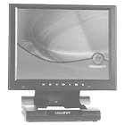
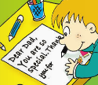
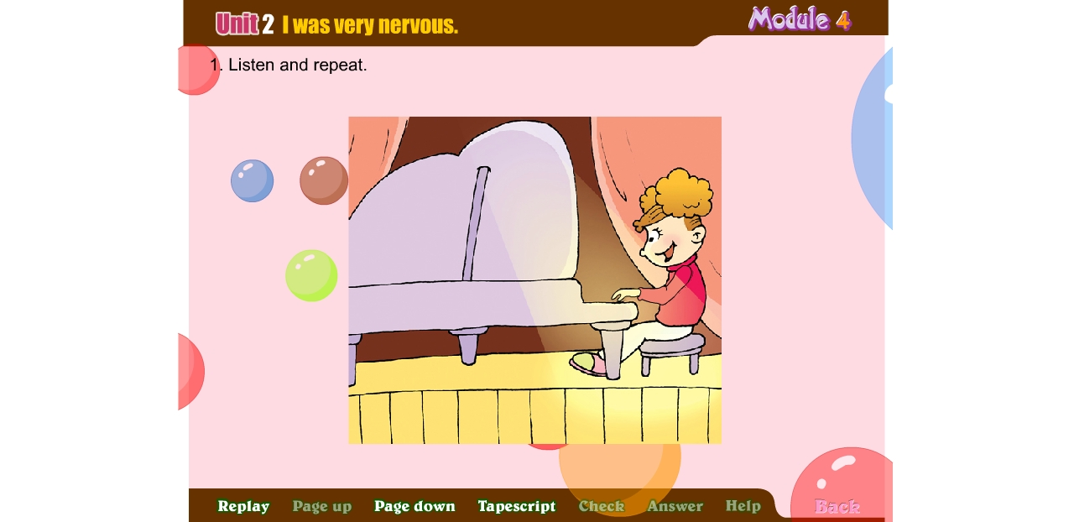
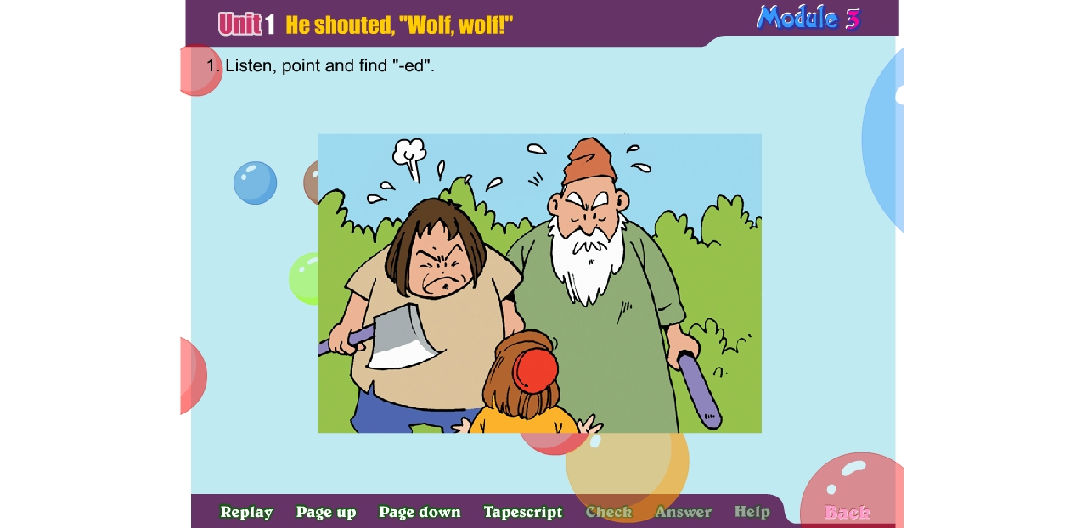


（ ） （ ） （ ） ( ) ( )

Ⅲ. 听音选句。把正确的选项填在前面的括号内。(每题2分，共10分）
( )1.A. Don’t play computer games. B. Don’t play ball games.
( )2.A. Is it 6 o’clock now? B. Is it 8 o’clock now?
( )3.A. This computer is beautiful. B. This is a beautiful computer. ( )4.A. Let’s have fun this Sunday！ B. Let’s have fun this Saturday！
( )5.A. New York is in the east. B. New York is in the west.
Ⅳ. 听短文判断正误。正确的写T, 错误的写F。（每题2分，共10分）
( ) 1. The children are having a picnic now.
( ) 2. Tom is playing the piano.
( ) 3. Sam is playing the violin now.
( ) 4. Today is Lingling’s mother’s birthday.
( ) 5. It’s a surprise party for Lingling’s mother.
笔试部分（共六大题，60分）
Ⅴ.单项填空。（每题1分，共10分）
( )1. This dress __________ nineteen yuan.
A. cost B. costs C. costing
( )2. Tom didn’t _________ to school. He was ill.
A. came B. went C. go
( )3. We will _________ there at ten o’clock.
A. are B. be C. were
( )4. Don’t _________ lies. Don’t be a bad child.
A. say B. tell C. talk
( )5. A: What’s __________now? B: Tom is singing.
A. happen B. happened C. happening
( )6. _________ the end, everyone clapped. I _________ happy.
A. In , am B. On ,were C. In , was
( )7. My mother _________ a present for me last Sunday.
A. buy B. bought C. buying
( )8. A: _________ did you go yesterday? B: I went to a shop.
A. When B. Where C. What
( )9. A: Why do you love Australia? B: ________ I love the animals.
A. Because B. So C. And
( )10. A: Let’s make a present for Mother’ s Day! B: __________
A. Thank you. B. That’s a good idea! C. That’s right.

Ⅵ. 根据所给语境，补全句子。（共15分）
A.根据汉语提示，结合语境，填入所缺单词。（每题2分，共10分）
1. A: What’s the ___________ (时间) now? B: It’s 4 o’clock.
2. Look! These are ___________ (邮件) from Amy to Daming.
3. They _____________ (说) English in the US.
4. It’s a _____________ (非常好的) day today. Let’s go to the park!
5. There are twelve ___________ (月份) in a year.
B.根据语境，选择恰当单词, 将序号写在横线上。（每题1分，共5分）
A. drawing B. writing C. favourite D. special E. making

Today is Father’s Day. Daming is _________ a card for his father. He’s _______books and birds. These are his father’s _______things. He’s _______ a message to his father, too.
Dear Dad,
You’re so_________. Thank you for everything.
Love, Daming

Ⅶ.情景反应。（每题2分，共10分）
( )1. Where are you going ?
A. We’re having a party.
B. Last year.
C. I’m going to the concert.
D. No, he doesn’t.
E. Yes, it was.
( )2. Was it Chinese music?
( )3. Does he live in Los Angeles?
( )4. When did she play in the concert?
( )5. What are you doing?

Ⅷ. 情景交际。选择答案的序号填写在空格处。(每题2分，共10分)
- Thank you, sir. B. Welcome to our factory, children!
- Sorry, sir. D. Don’t touch the machines, please!
- What does this machine do, sir?

A: ___________________ These machine make crisps.
B: ____________________
A: It washes the potatoes. Look ! This machine cuts the potatoes.
B: _____________________They are dangerous.
A: ___________________
A: This machine puts the crisps in the bags.
B: It’s fun.
…………………………………………………密………………………………封……………………………………线…………………………………………………
A: You are a very good class .You can each have a bag of crisps.
B: ____________________

IX. 阅读理解，判断正(T)误(F)。（每题2分，共10分）
My family is not very big. There are only three cats. I’m a white cat. People call(称呼) me Snow-white. My husband(丈夫) is a black cat. People call him Captain Black Cat (黑猫警长). We have a beautiful daughter(女儿). Her name is Lily. She is black and white. She’s two years old. We live a happy life. We will work hard to eat the mouse. We will let people live in a happy life in this house.
( )1. There are four cats in the cat’s family.
( )2. Mother Cat is white.
( )3. Mother Cat and Father Cat have a daughter.
( )4. Lily is three years old.
( )5. The cats will work hard to eat good food.

Ⅹ.想一想，写一写。(共5分）
同学们，动物是我们人类的好朋友，我们应该爱护动物。请你写一段话，介绍你最喜欢的动物，写写它们的生活习性吧！
要求：内容完整，语言顺畅，字迹工整，正确使用大小写。
提示词: kangaroos； koalas; cats；dogs; cute；clever；lovely；
Australia；water；tree；grass；bones…

My Favourite Animal
My favourite animal is _______________. They are ________________.
They live in _____________________. ____________________________.

四年级英语听力题签
注意：每道听力试题读两遍，听力时间控制在15分钟内。
Ⅰ. 听音选词。请选出你所听到的单词。
1. Look! This country is the US.
2. Don’t walk on the grass.
3. I am going to visit some museums.
4. It’s a surprise party for our mothers.
5. North and south, let’s have a rest.
Ⅱ. 听音标号。用数字标出图片的先后顺序。
- The girl played the piano yesterday.
- I’ll send you a postcard from London.
- This computer is expensive.
- The people ran up the hill. There was no wolf.
5. It’s Father’s Day. He’s writing a message to his father.
Ⅲ. 听音选句。把正确的选项填在前面的括号内。
1. Don’t play ball games here.
2. Is it 8 o’clock now?
3. This computer is beautiful.
4. Let’s have fun this Saturday!
5. New York is in the east.
Ⅳ. 听短文判断正误。正确的写T, 错误的写F。
Daming: Hi, Lingling! What are you doing?
Lingling: Hi, Daming. We’re having a party now. Amy is playing the piano.
Daming: What’s happening now?
Lingling: Oh, Tom is singing. Can you hear?
Daming: Yes.
Lingling: And now Sam is playing the violin.
Daming: I can hear the violin. Is it your mum’s birthday?
Lingling: No, it’s Mother’s Day today. It’s a surprise party for our mother.
Daming: You are great!

听力部分到此结束！

四年级英语参考答案及评分标准

听力部分
Ⅰ. (2×5＝10分) CBCCB
Ⅱ. (2×5＝10分) 3—-5—-1---4---2
Ⅲ. (2×5＝10分) BBABA
Ⅳ. (2×5＝10分) F F T F T

笔试部分
Ⅴ. (1×10＝10分) BCBBC CBBAB
Ⅵ. A组(2×5＝10分)：1. time 2. emails 3. speak 4. great 5. months
(请注意画线黑体部分，如果没有形式的变化将扣1分，其他单词完全准确方可得2分。）
B组(1×5＝5分)： EACBD
Ⅶ. (2×5＝10分) C E D B A
Ⅷ. (2×5＝10分) B E D C A
Ⅸ. (2×5＝10分) F T T F F
Ⅹ. (5分) 作文内容请评卷教师自行把握
(请注意第1-3空各1分，最后一个空2分)

备注：卷面满分为100分。（听力40分，笔试60分。）
优秀：90---100
良好：80---89
及格：60---79
不及格：0---59

2021年 7月 13 日

