四块石小学2019~2020学年度第二学期期末质量监测
小学四年级 英语
听力部分 (共四大题 40分)

Ⅰ. 听音选词。请选出你所听到的单词。（每题2分，共10分）
B. class
B. village
B. cinema
B. Mr
B. touch

C. grass
C. hill
C. China
C. sir
C. tell

A. glass
A. field
A. concert
A.Miss
A. talk

( )1.
( )2.
( )3.
( )4.
( )5.

Ⅱ.听音标号。用数字标出图片的先后顺序。（每题2分，共10分）
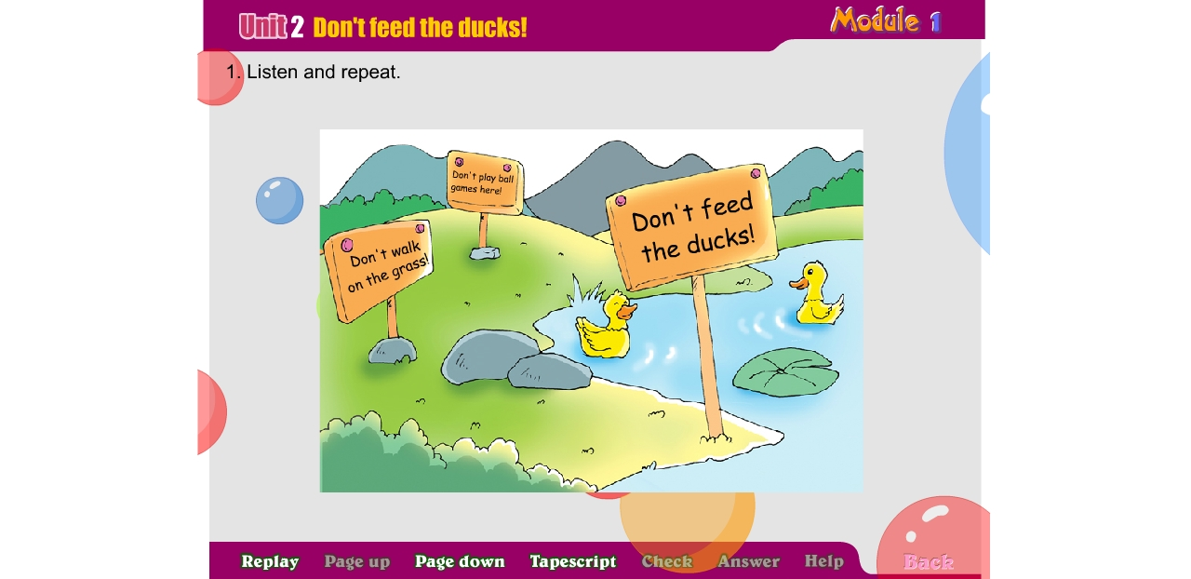
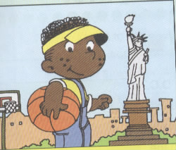
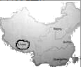

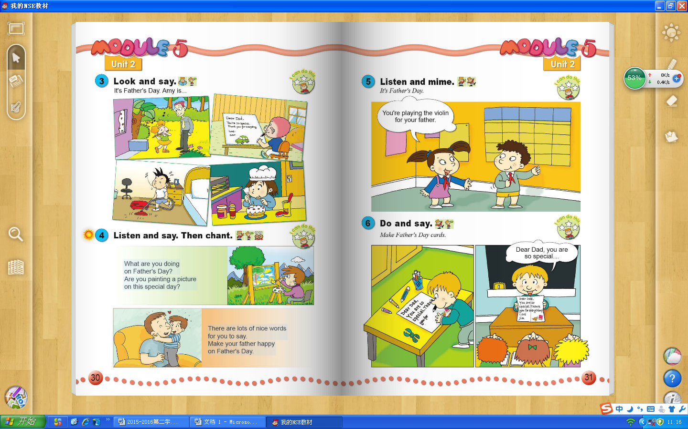

（ ） （ ） （ ） （ ） （ ）
Ⅲ. 听音选句。把正确的选项填写在前面的括号里。（每题2分，共10分）
（ ）1. A. I’m going to go back to England.
B. I’m going to go back to China.
（ ）2. A. New York is in the east . B. New York is in the west.
（ ）3. A. This computer is powerful. B. This computer is cheap.
（ ）4. A.We’re having a party. B. We’re going to have a party.
（ ）5. A. Let’s have fun this Sunday. B. Let’s have fun this Saturday.
Ⅳ.根据所听短文内容判断对错，对的写“T”，错误的写“F”（每题2分，共10分）
( )1.Today is Mother's Day.
( )2.Mary is making some biscuits for her mother.
( )3.Mary will make a card for her mother.
( )4.Trees and flowers are her mother’s favourite things.
( )5.Mary will write a letter to her mother.

笔试部分（共六大题，60分）
Ⅴ.单项填空。将正确答案的序号填写在前面的括号里。(每题1分，共10分)
( )1. Look! The boy looks ______ his father.
A. after B. like C. at
( )2. This pen costs four hundred yuan. It is very________.
A. cheap B. expensive C. old
( )3. Don't tell_______. It is very bad.
A. lies B. lie C. lesson
( )4. Don’t __________ball games here ! It’s dangerous.
A. plays B. playing C. play
( )5. Fangfang plays the _________every day.
A. football B. violin C. basketball
( )6. Why do you like koalas? __________they are very, very lovely.
A. Because B. So C. But
( )7. Beijing is the _________of China. We love China.
A. capital B. country C. museum
( )8.It’s ________ today.
A. fathers’ day B. Father’s Day C. Fathers’Day
( )9.A: What’s __________now? B: Tom is singing.
A. happen B. happened C. happening
( )10. Look! The boys are laughing and _______________.
A. claping B. clap C. clapping
Ⅵ.词语运用。（共20分）
A.请根据所给语境写出正确的单词。(每空1分，共10分)
- What _________（语言）do they _________(说）there?
- __________(欢迎) to Changhai. It’s very beautiful.
- There are twelve_________(月，月份) in a year.
- I can send an _________(电子邮件) to my grandma.
- The mouse _________(跑) away，because he saw a cat.
- Someone is crying in the next room. Can you _______?(听见)
- Look! This machine cuts the _________.(土豆)
- Let’s ______(与……见面) at the zoo at 10. Then we will see the animals there.
- What is the _______?(时间) It’s 11:30.

B. 选择适当的单词或短语完成下列句子，并写在横线上。（每题2分，共10分）
Mother’s Day , Australia , East , everyone , restaurant

1.________or west, home is the best.
2. On_________________,what did you do for your mother?
3. Koalas live in__________. They are very cute.
4. It's time to have lunch. Let's eat in this___________.
5. At the end of the concert, ________ clapped and I was happy.
Ⅶ.情景反应。（每题2分，共10分）
( )1. Was it Chinese music? A. We’re having a party.
( )2. Where will he go? B. Yes, it was.
( )3. What are you doing? C. The UK.
( )4.Do you like Chinese music? D. Eighteen yuan.
( )5. How much does it cost? E. Yes,very much.

Ⅷ.情景交际。根据对话内容，从方框中选择正确选项，将其序号写在横线上。
(每题2分，共10分)
Lingling: Let's make an English newspaper.
Amy： 1.__________
- I'm good at English.
B.That's a great idea.
C.Yes, I will.
D.I'll draw the pictures.
E. What will you do, Sam?
Sam: Yes, it can be our school.
Daming: I'm good at Art. 2._________
Amy: 3.______ I'll write the reports.
Lingling: 4.________
Sam: I'll cut the paper.
Amy: Will you stick the pictures on the newspaper. Lingling?
Lingling: 5._________
Amy, Sam, Lingling &. Daming: Wow! Our English newspaper is fantastic.
Ⅸ.阅读短文，判断正误，正确的写“T”，错误的写“F”。（每题1分，共5分）
Once upon a time,there was an emperor(皇帝).He liked new clothes very much.
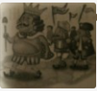
There were two swindlers(骗子). They said, "We will make
very good clothes for the emperor. But stupid (傻的) people
can’t see the clothes. ”The emperor came and could not
see the clothes. But he said,"The clothes are very good. I like
them very much.”All the people said,"You look very nice."
But a little boy said,"Don't tell lies! He has nothing on (没穿衣服) al l!"At last,the two swindlers ran away and the emperor was very angry.
( )1. Two swindlers made good clothes for the emperor.
( )2. The emperor was clever, so he saw the new clothes.
( )3. The people told lies.
( )4. A little boy didn't tell lies.
( )5. The emperor was very proud at last.
Ⅹ.想一想，写一写。(共5分）
暑假将至，假如你是Fangfang，请给你的朋友Lingling写一个明信片，介绍你的暑假计划。
提示词：the US / the UK / Shanghai/ Dalian / Beijing…
send you a postcard / go swimming / read books/ listen to music /see kangaroos/ fly a kite…

Dear Lingling,
This summer, I will go to______________. I’ll ___________________. ______________________________. _________________________.
I’ll be happy.
Love,
Fangfang

温馨提示：亲爱的同学们，试卷已完成，要认真检查哦，
祝大家取得好成绩！加油！

四年级英语听力题签：
注意：每道听力试题读二遍，听力时间控制在15分钟内。
听力部分（40分）
Ⅰ、听音,选出你所听到的单词，将其序号填入括号内。
1. Don't walk on the grass!
2. The boy ran to the village.
3. I listened to Chinese music in a concert.
4. Thank you, sir! We all like your crisps.
5.Don’t touch the machines,please!
Ⅱ.听音标号。用数字标出图片的先后顺序。
1.He lives in the east of the US.
2.It’s Father’s Day. He’s writing a message to his father.
3.I’ll send you a postcard from London.
4.It says,“Don’t feed the ducks.”
5.This is a map of China.Lhasa is in the west of China.
Ⅲ. 听音选句。把正确的选项填写在前面的括号里。
1.I’m going to go back to England.
2.New York is in the east.
3.This computer is powerful.
4.We’re going to have a party.
5.Let’s have fun this Saturday.
Ⅳ.根据所听短文内容判断对错，对的写“T”，错误的写“F”
My name's Mary. I'm an English girl.My mother is a doctor. Today is my mother's birthday. She likes eating cakes. I' m making a cake for my mother. Then I'm going to make a card for her. I will draw flowers and trees. These are my mother’s favourite things. And I will write a message to my mother, too. It will be a nice birthday present.
听力部分到此结束！

四年级英语参考答案

听力部分
Ⅰ. (2×5＝10分) 1.C 2.B 3.A 4. C 5.B
Ⅱ. (2×5＝10分) 5—4—1—3 —2
Ⅲ. (2×5＝10分) 1.A 2. A 3. A 4. B 5.B
Ⅳ. (2×5＝10分) 1. T 2. F 3. T 4.T 5. F

笔试部分
Ⅴ. (1×10＝10分) BBACB AABCC

Ⅵ. A. (1×10＝10分)
1.language speak 2. Welcome 3.months 4. email 5.ran
6. hear 7. potatoes 8. meet 9.time
（请注意画线红体部分,如果没有相应形式的变化将各扣0.5分，其他单词完全准确方可得1分。）
- （2×5=10分）
1. East 2. Mother’s Day 3.Australia 4.restaurant 5.everyone
（注意字母的大小写，抄写完全正确方可得2分，有丢字母落字母的的各扣0.5分）
Ⅶ. (2×5＝10分) B C A E D
Ⅷ. (2×5＝10分) B D A E C
Ⅸ. (1×5＝5分) 1. F 2. F 3. T 4. T 5.F
Ⅹ.(5分)
第一、二横线各1分，第三、四横线各1.5分。
备注：卷面满分为100分。（听力40分，笔试60分。）
优秀：90---100
良好：80---89
及格：60---79
不及格：0---59

