…………………………………………………密………………………………封……………………………………线…………………………………………………
序号
长海县2019~2020学年度第二学期期末质量检测
学校
班级
姓名
小学五年级 英语 完成时间：80分钟
题  号 | 听力部分 |  |  |  | 笔试部分 |  |  |  |  |  | 总 分
题  号 | Ⅰ | Ⅱ | Ⅲ | Ⅳ | Ⅴ | Ⅵ | Ⅶ | Ⅷ | Ⅸ | Ⅹ
得
分

听力部分（共四大题，30分）
Ⅰ.听音，找出句子中含有的单词，将序号写在前面的括号内。（每题1分，共5分）
- driver B. draw
- policeman B. player
- delicious B. duck
- show B. subject
- classmate B.classroom

( ) 1.
( ) 2.
( ) 3.
( ) 4.
( ) 5.

密 封 线 内 不 要 答 题


Ⅱ.听音，标号。用数字标出图片的先后顺序。（每题1分，共5分）
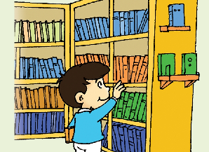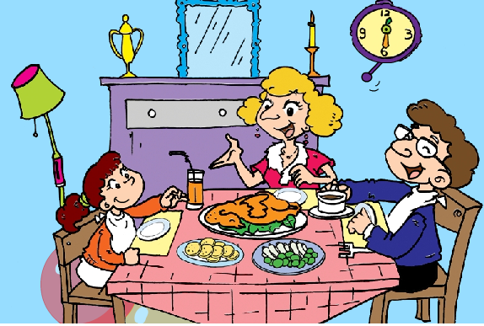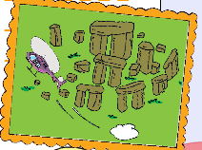
( ) ( ) ( ) ( ) ( )
Ⅲ. 听问句，选答句。将正确答案序号填在括号内。（每题2分，共10分）
( )1. A. She works in a shop. B. She drove a bus.
( )2. A. She had eggs and sausages. B. I’ve got an email from Lingling.
( )3. A. No, I haven’t. B. Yes, I do.
( )3. A. I’ll be home at 7 o’clock. B. We’ll see lots of very big stones.
( )4. A.I ate fish and chips. B. I’ll go to the airport.
Ⅳ.听录音，判断正误，在正确句子前的括号里写"T"，错误的句子前写"F"。（每题2分，共10分）
( )1. My grandpa worked in an office.
( )2. My grandma worked in a hospital.
( )3. My father works in a factory.
( )4. My mother works in a shop.
( )5. We are a happy family.
笔试部分（共六大题，70分）
Ⅴ.单项选择。（每题1分，共15分）
( )1. He ______ a doctor before.
- was B. is C. are
( )2. He can ______ the flute.
- played B. play C. playing
( )3. He worked in ______ office.
- an B. a C. /
( )4.--- ______ she got a book?
--- Yes, she has.
- Has B. Have C.Had
( )5. I carry my school bag______ my shoulder.
A.over B. in C. at
( )6. ______ Saturday, we are going to see the animals.
- In B.On C. At
( )7. We’ll see ______ big stones.
- lots of B. lot of C. a lots of
( )8. He ______ very busy.
- are B. is C. am
( )9. Daming’s grandma lives ______ the US.
- in B. on C. from
( )10. I ______ on the beach last week.
- play B. playing C. played
( )11. I can play ______ the toys.
- on B. with C. for
( )12. I’ll ______home at 7 o’clock.
A.am B. is C. be
( )13. Last week, we ______ to a children’s theatre.
- go B. went C. going
( )14. --- ______ will you go tomorrow?
---I’ll go to the airport.
- Where B. What C. Who
( )15. ______ you got the Harry Potter DVD?
- Has B. Have C. Had
Ⅵ.根据语境提示，用词汇的适当形式完成下列句子。（每题1分，共10分）
- I sent you English books. Did you __________(阅读) them?
- My favourite __________(季节) is spring.
- Look at the green one. It’s __________.(轻的)
- My schoolbag is red and blue. I carry it on my __________.(后背)
- It’s a very old __________(地方). It’s about five thousand years old.
- They eat __________(鸡肉), potatoes and other vegetables.
- ---How will you __________(到达) there?
---By car.
- The actors __________(讲) lots of jokes.
- My father goes to work at 8 o’clock every __________(晚上).
- I love winter. It’s cold. I can play with the __________(雪).
Ⅶ.句子理解。（A部分每题2分，B部分每题2分，共20分）
A. 根据问句找出相对应的答句，将序号填入题前括号内。
( )1. What did she do ? A. I’m going to clean my car.
( )2. What are you doing? B. Some animals .
( )3. What music does he play ? C. We’re taking some photos.
( )4. What will we see in the zoo ? D. She played on the beach.
( )5. What are you going to do ? E. He plays Chinese music .

B.选择词的适当形式填空。
- In winter, I can ______(wearing / wear) T-shirt.
- Have you _______ (get / got) a video?
- I want fish. He ______ (wants / want) noodles.
- I sent you English books. Did you read ______(they / them)?
- What did she ______ (has / have) for breakfast?
Ⅷ.情景交际。根据对话内容，从方框中选择正确选项，将其序号写在横线上。（每题2分，共10分）
Amy: Excuse me.
Librarian: I’ll look on the computer. Sorry, we haven’t got the DVDs.
Amy: Oh good. Where are they?
Librarian: __________________
Amy: Harry Potter is my favourite.
Librarian: Your library card, please.
Amy: ___________________
Librarian: Please give the books back in two weeks.
Amy: __________________
A. But we have got the books.
B. Here you are.
C. I’ll show them to you.
D. I will. Thank you.
E. Have you got the Harry Potter DVDs?
. H .And then her friends are going tio go home. e will be home at seven o’clock. E. Is he very busy?

Ⅸ.阅读理解。（共10分）

阅读短文，判断正误。正确的写“T”，错误的写“F”。
You can do lots of things in English libraries. You can borrow the books, videos and CDs. You can use the computers. You can do your homework. But you can’t talk to your friends.
( )1. You can do nothing in English libraries.
( )2. You can only borrow the books in the libraries.
( )3. You can use the computers.
( )4. You can do your homework.
( )5. You can not talk to your friends in the libraries
Ⅹ.书面表达。（5分）
同学们，一年有四季，哪个是你最喜欢的季节？根据下面的提示和要求，请你以“My favourite season”为题，用英文介绍你最喜欢的季节。
提示：1.What’s your favourite season?
- Why do you like it?
- What can you do in the season?
要求：1.语言准确流畅，符合逻辑；2.书写规范，字迹工整；3.不少于5句话，可适当发挥。
_____________________
______________________________________________________________________________________________________________________________________________________________________________________________________________________________________________________________________________________________________________________________________________________________

