2019—2020学年度第二学期期末质量检测
…………………………………………………密………………………………封……………………………………线…………………………………………………
四年级 英语
学校
班级
姓名
（总分：100分 时间：60分钟）
题号 | 听力 |  |  |  | 笔试 |  |  |  |  |  | 总分
题号 | I | II | III | IV | V | VI | VII | Ⅷ | Ⅸ | Ⅹ
得分
听力部分（共四大题，40分）
Ⅰ.听句子，选出你听到句子中的单词。（每小题2分，共10分）
( )1. A. choose B. cheese C. country
( )2. A. bored B. bought C. because
( )3. A .day B. dad C. dangerous
( )4. A. potato B. put C. proud
( )5. A. each B. emails C. expensive
Ⅱ．听音标号。用数字标出图片的先后顺序。（每题2分，共10分）
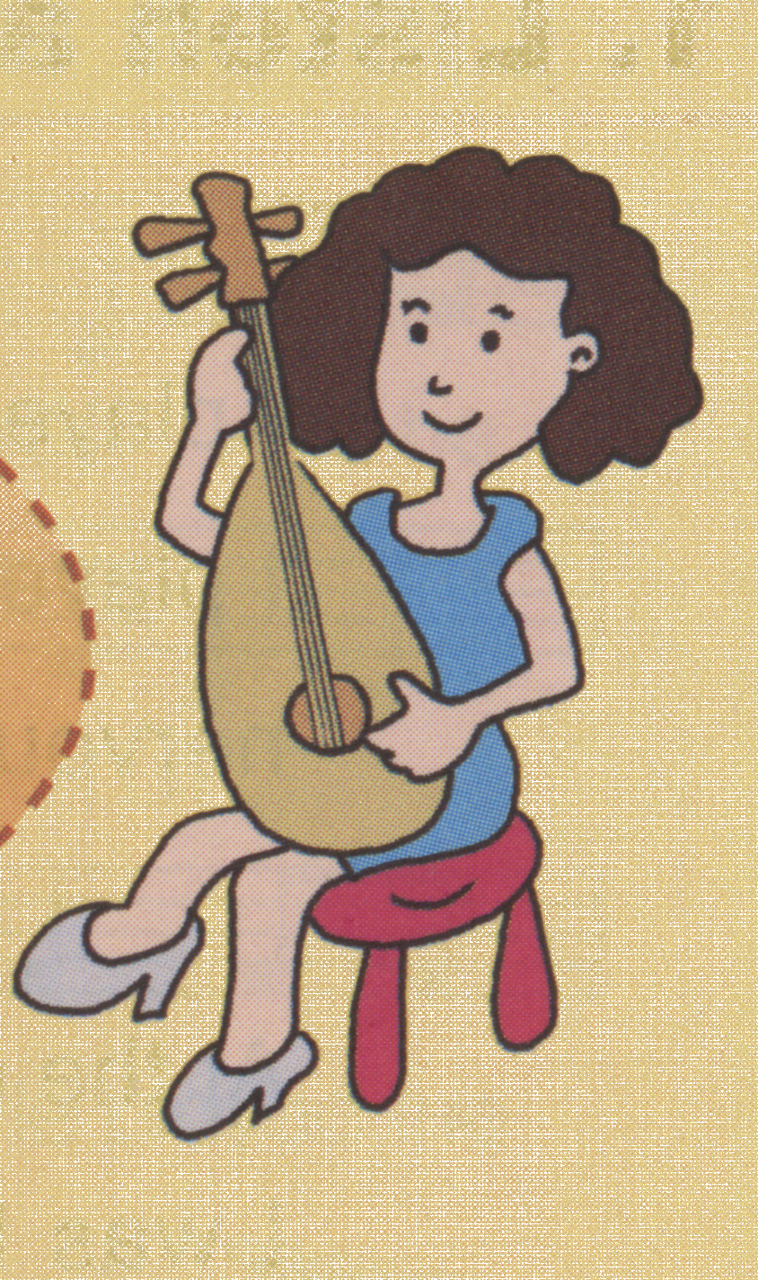
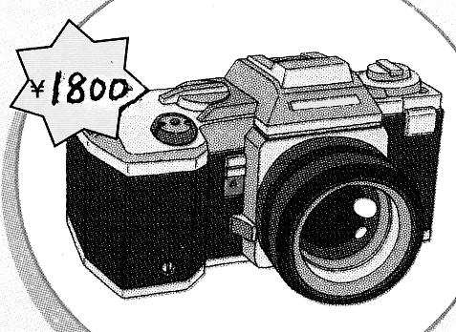
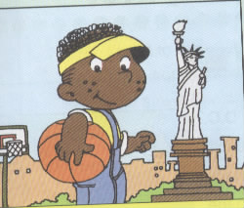

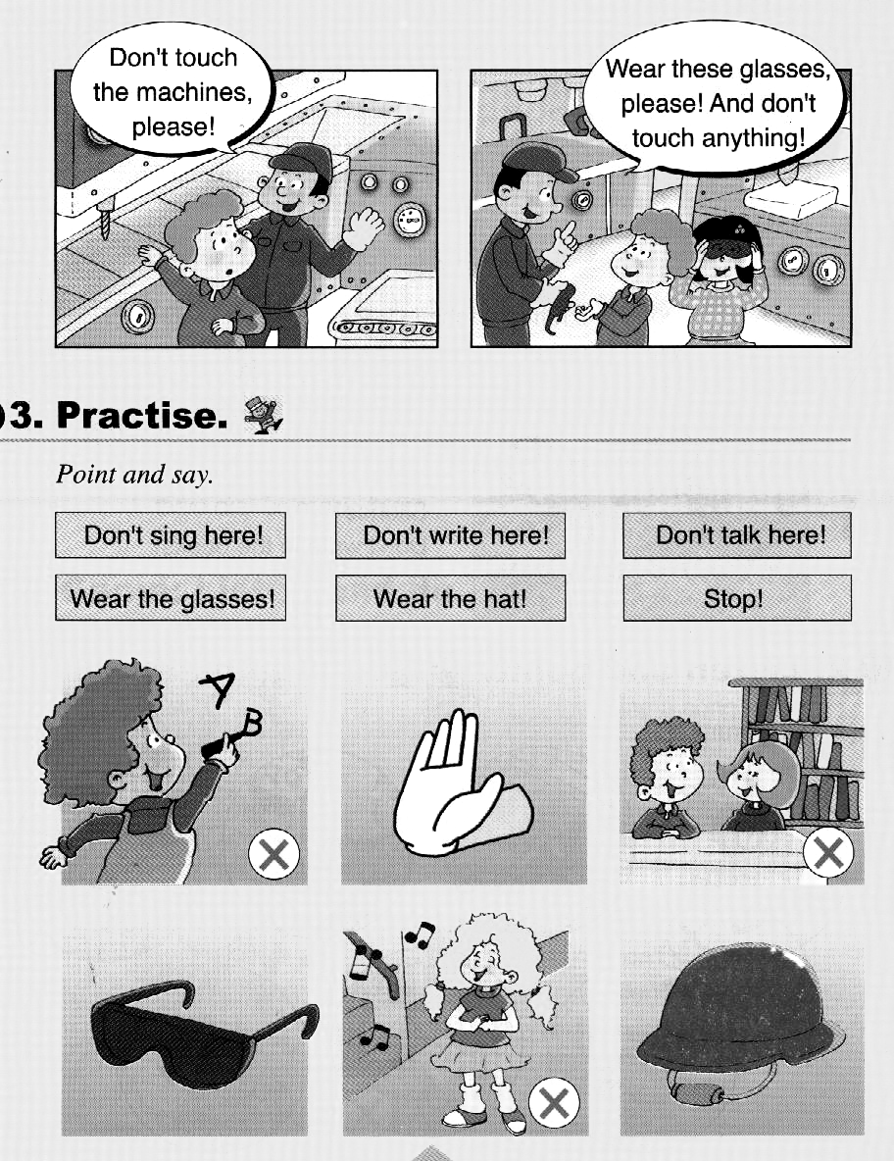

( ) ( ) ( ) ( ) ( )
Ⅲ. 听音选出你所听到的句子，将其序号填在前面的括号里。（每题2分，共10分）
( )1. A. It costs 1800 yuan. B. It costs 1700 yuan.
( )2. A. This computer is cheap. B. This computer is expensive.
( )3. A. Wear these glasses, please! B. Don’t wear these glasses, please!
( )4. A. He lives in the west of America. B. He lives in the east of America.
( )5. A. Why do you love kangaroos? B. Why do you love koalas?
Ⅳ.听短文判断.正确的写“T”,错误的写“F”（每小题2分，共10分）
( )1.Dongdong will make a newspaper with his friend.
( )2. Fangfang is good at English.
( )3. Taotao is good at Art.
( )4. Dongdong will cut the paper.
( )5. Haohao will draw the pictures.
笔试部分（共六大题，60分）
Ⅴ. 选择填空，将序号填在括号里。（每题1分，共10分）
( ) 1. Once upon a time, there was ________ old man.
A. a B. an C. the
( ) 2. Look, this ________ puts the crisps in the bags.
A. book B. computer C. machine
( ) 3. Don’t be ________. You’ll win the game.
A. happy B. nervous C. proud
( ) 4. The seat ________. The boy fell and cried.
A. break B. breaks C. broke
( ) 5. Pinocchio (匹诺曹) always ________. Nobody believes (相信) him.
A. reads books B. tells lies C. helps people
( ) 6. Lingling is painting a picture ________ her mother.
A. to B. for C. from
( ) 7. Sanya is in the ________ of China. It’s warm in winter.
A. west B. north C. south
( ) 8. —________ do you like pandas?
—Because they are cute.
A. What B. When C. Why
( ) 9. —Do you want to listen to Chinese music?
—________
A. Yes, it is. B. Yes, please. C. Yes, I can.
( ) 10. —Let’s make a present for Mother’ s Day!
—________
A. Thank you. B. That’s a good idea! C. That’s right.
Ⅵ. 根据所给语境，补全句子。（共15分）
- 根据汉语提示，结合语境，填入所缺单词。（每题1分,共5分）
1. Look at this machine. It _________ (放) the bags in the box.
2.What _________(语言)do they speak there?
3. There are twelve ____________ (月)in a year.
4.They are __________(鼓掌).
5.It's a __________(出乎意料) party.

B.选择恰当的单词填空。（每题2分，共10分）
ran bought went was ate saw

Tilly was a mouse. Yesterday, she ________into a shop. She _________some cheese. Then she _________the cheese. Tilly _______a cat . She was scared. Tilly broke the door and _________away.
Ⅶ. 根据问句选答句，将序号填在括号里。（每小题2分，共10分）
1. ( )What does this machine do? A. It washes the potatoes.
2. ( )What’s happening now? B. Because I love Australian animals.
3. ( )Why do you like Australia? C. Tom is singing.
4. ( )Where is Los Angeles? D. They speak English.
5. ( )What language do they speak? E. It’s in the west of America.
Ⅷ. 情景交际。将正确答案的序号填在横线上（每题2分，共10分）
(On the phone)
Daming: What are you doing, Lingling?
Lingling: 1____________
Daming: What's happening now?
Lingling: Amy is playing the piano. And Tom is singing. 2____________
Daming: Yes, I can. I can also hear the violin.
Lingling: 3. ____________He's good at music.
Daming: Is it your mum's birthday?
Linging: NO. 4____________ It's a surprise party for our mothers.
Daming: Sounds great.
Lingling: They are very happy. 5______________
A. Can you hear?
B. We're having a party.
C. It's Mother's Day today.
D. They are clapping.
E. Sam is playing the violin now

IX. 阅读理解。将答案序号填在括号里。（每小题2分，共10分）
A beggar(乞丐) is sitting by the street. He wears sunglasses and asks for money. He looks like a blind(盲的)man.
密 封 线 内 不 要 答 题
A drunk man walks by and gives him 100 yuan. The drunk man walks away. Then, he looks back. The "blind" beggar is looking at the money carefully! The drunk man feels angry. He runs to the beggar and takes the money back. " Why you tell lies? You are not blind, "he asks. The beggar says, "I’m sorry. I’m here to help my friend. He is blind. He just goes to the toilet and will come back soon. But I’m a beggar, too. I’m a mute(哑巴).”
“Oh, I see. You are really poor,”says the drunk man. He gives the money back to the beggar and walks away.
…………………………………………………密………………………………封……………………………………线…………………………………………………
( )1. Why does the beggar wear sunglasses?
A .Because it's so hot. B. Because he is a blind man.
C. Because he wants to act as a blind man and ask for money.
( )2. How much did the drunk man give to the beggar?
A.S100 B.￥100 C.￥1
( )3. Which one is TRUE?
A. The beggar doesn't tell lies. B. The beggar is helpful
C. The beggar isn't a blind man or a mute.
( )4. Can you guess the Chinese meaning of “poor”?
A.幸运的 B.可怜的 C.倒霉的
( )5. Is the drunk man a fool?
A. Yes, he is . B No, he isn't. C. I don't know.
X.写作园地。（共5分）
动物是人类的朋友。因此，我们要爱护动物。同学们，你们都喜欢哪些动物呢? 请以“ My Favourite Animal”为题介绍动物的习性。
要求:1.表达准确，内容完整，语言顺畅，字迹工整，正确使用大小写、间距和标点符号; 2.不少于五句话。
________________________________________________________________________________________________________________________________________________________________________________________________________________________________________________
____________________________________________________________
2019-2020学年度第二学期期末质量测试卷
四年级英语听力题签
Ⅰ. 听音选词。请选出你所听到的单词。
1. Look at the computers. It’s difficult to choose.
2.The boy looked after the sheep. And he was very bored.
3.It’s Mother’s Day today.
4.I was happy. And I was very proud ,too.
5.Now I can send emails to you.
Ⅱ. 听音标号。用数字标出图片的先后顺序。
1. This camera is expensive.
2. Don’t write here!
3. The mother kangaroo has a special bag for her baby.
4. Mum played the pipa in the concert.
5. He lives in the east of the US.
Ⅲ. 听音选出你所听到的句子，将其序号填在前面的括号里。
1. It costs one thousand seven hundred yuan.
2. This computer is expensive.
3. Wear these glasses, please!
4. He lives in the east of America.
5. Why do you love koalas?
Ⅳ.听短文判断.正确的写“T”,错误的写“F” 。
Hi ! I’m Dongdong. Next Monday ,I’ll make a poster with my good friends , Fangfang , Taotao and Haohao. Fnagfang is good at Chinese . She will write the report. Taotao is good at Art. He will draw the pictures. I will cuy the paper. And Haohao will stick the pictures together . Our poster will be fantastic.

2019-2020学年第二学期期末质量检测
四年级英语参考答案及评分标准
听力部分
Ⅰ. (2×5＝10分) AAACB
Ⅱ. (2×5＝10分) 42153
Ⅲ. (2×5＝10分) BBABB
Ⅳ. (2×5＝10分) F F T T F
笔试部分
Ⅴ. (1×10＝10分) BCBCB BCCBB
Ⅵ.
A组(1×5＝5分)：1.puts 2. language 3. months 4. clapping
5. surprise
(请注意画线黑体部分，如果没有形式的变化将扣0.5分，其他单词完全准确方可得1分。）
B组(2×5＝10分)：1. went 2.bought 3.ate 4. saw 5. ran
Ⅶ. (2×5＝10分) ACBED
Ⅷ. (2×5＝10分) BAECD
Ⅸ. (2×5＝10分) CBCBA
Ⅹ. (5分)
教师依情况给分数。

备注：卷面满分为100分。（听力40分，笔试60分。）
优秀：90---100
良好：80---89
及格：60---79
不及格：0---59

