小学英语五年级（下）期末测试卷（一起）[2017.07]
班 级
姓 名
同学们，一个学期的学习快要结束了，你想了解自己的学习情况吗？那就在这里测试一下吧！只要你像平时那样开动脑筋、认真思考，就一定能取得好成绩。相信自己，开始答题吧！
听力部分（30分）
Ⅰ.听音，选出你所听到的单词，将其序号填入括号内。（每题1分，共8分）
( ) 1. A. borrow | B. build | C. bench
( ) 2. A. fish | B. fan | C. fire
( ) 3. A. theatre | B. think | C. ticket
( ) 4. A. study | B. show | C. scissors
( ) 5. A. point | B. player | C. pound
( ) 6. A. drive | B. drove | C. dish
( ) 7. A. chick | B. clean | C. circle
( ) 8. A. hope | B. half | C. heavy
Ⅱ.听音，用数字（1、2、3、4、5）给下列图片重新排序。（每题2分，共10分）

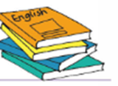


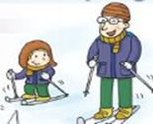
( ) | ( ) | ( ) | ( ) | ( )
Ⅲ. 听对话，选答句。（每题1分，共6分）
( ) 1. A. Play basketball. B. Go swimming.
( ) 2. A. Last year. B. Last summer.
( ) 3. A. By car. B. By bus.
( ) 4. A. Yes, she will. B. No, she won’t.
( ) 5. A. In the hospital. B. At home.
( ) 6. A. We saw some monkey. B. We’ll see some monkey.
Ⅳ.听音理解短文。（每题1分，6分）
( ) 1. My father is a _________.
A. doctor B. teacher
( ) 2. He gets up at _________ every morning.
A. 7:40 B. 6:30
( ) 3. He usually has ________ classes in a day.
A. five B. three
( ) 4. He often has lunch at ________.
A. school B. home
( ) 5. In the evening he usually _________.
A. do some exercises B. do some reading
( ) 6.He works in a school.
A. middle B. primary
笔试部分（70分）
Ⅴ.词汇运用。（共15分）
1. I （绘画，画）a fat cat on the paper.Then I (给……涂颜料）it yellow.
2. I like reading the books , they are very ______________（有趣的）.
3. The schoolbag is ______________(轻的). I can carry it on my back.
4. You're clever.Maybe you will find the （答案）.
5． Grandma, I can c________ the bag. It’s very l .
6． My favorite s________ is history. What about yours?
7． Last Sunday, we went to the zoo. It took only one h_______ by bus.
8． My father is an a_______. He is very b_______.
9. Last summer, I went to Mount Tai. I m______ my classmates there.
VI. 单项选择 请根据语境选择最佳选项并将序号填入括号（共15分）
（ ）1. I’ve got _______email from Daming. It’s about ______English food.
A. an ; an B. a; 不填 C. an; 不填
（ ）2.We want to borrow some Harry Potter books. They’re _______ favourite.
A. us B. their C. our
（ ）3. My father is a policeman. He ______ at 7:30 every morning.
A. went to work B. goes to work C. go to work
（ ）4. Look, Mimi _________my chocolate.
A. is eating B. ate C. eating
（ ）5. You _______ to your friends in the library.
A. can’t talk B. couldn’t talk C. can talk
（ ）6. It’s summer now. The temperature is ________.
A. low B. high C. hot
（ ）7. ----What did Ann have for dinner? ----_________.
A. Fishes, chips and eggs B. Fish, chip and eggs
C. Fish, chips and eggs
（ ）8. The schoolbag is nice and big, _____it’s too expensive.
A. and B. but C. because
（ ）9. It’s a quarter______ seven. I ______ home at seven o’clock.
A. to... will be B. past...will be C. to... will
（ ）10. ----_______ will you go tomorrow? ---- At 8o’clock in the morning.
A. What B. Where C. When
VII.句子理解。（共15分）
- 根据问句找出相对应的答句，将序号填入题前括号内。
( ) 1. Where does she work? | A. I had meat and rice.
( ) 2. What did you have for dinner? | B. It’s 30 pounds.
( ) 3. When does Sam have breakfast? | C. She works in a hospital.
( ) 4. How will we get the zoo? | D. He has breakfast at 7.
( ) 5. How much is the black bag? | E. By car.

- 根据语境提示，选词并用其恰当的形式补全下列短文。
amazing wait photo over go
Last Saturday, Lingling ________ to Stonehenge. There was a very surprise_________ for her. She took a short helicopter_________ it. It was __________. And She took some nice_________ there. She sent them to her friend—Daming.
Ⅷ.情景交际（每题2分，共10分）
Grandma : Are you ready for your trip tomorrow?
Amy : I don’t know, Grandma.
Grandma :
Amy : My clothes, my shoes, some presents and my ticket.
Grandma : And
A. where will you go tomorrow?
B. I’ll go to the airport.
C. What did you put in your bag?
D. Who is going to the train station with you?
E. When will you leave tomorrow?
F. What time did you leave?
G. I ‘ll go to the train station.

Amy : Then I’ll take the train to Beijing.
Grandma :
Amy : At 7 o’clock in the morning.
Grandma :
Amy : Dad!
Grandma : Great! You are ready for your trip!
See you in Beijing, Amy!
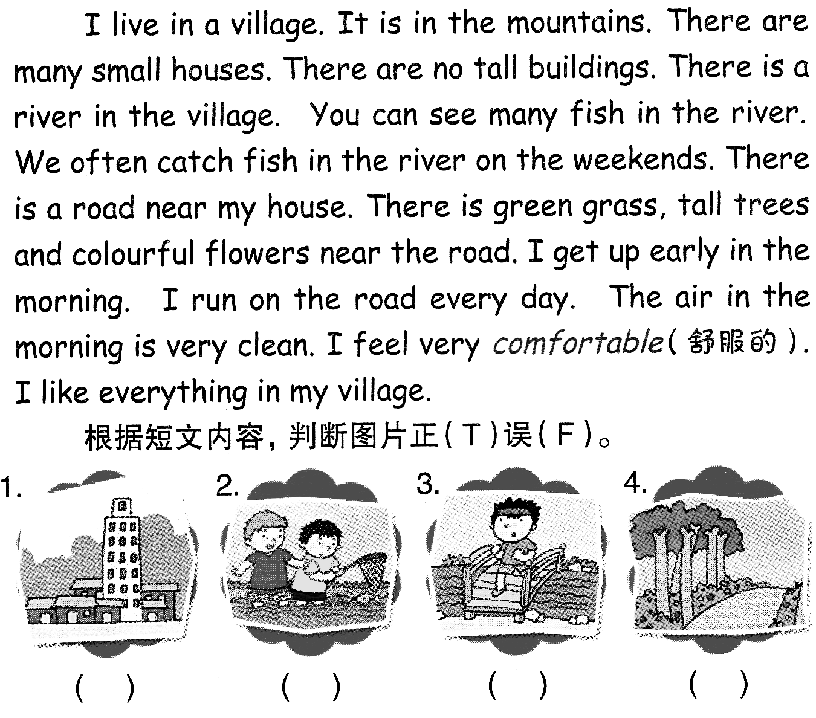
Ⅸ.阅读理解（共15分）
(A)阅读短文，并判断正误，正确的在括号中写T，错误的写F（5分）
My family lives on this street. In the morning, my father goes to work and all the children go to school. My mother takes us to school every day. She does the housework. She always has her lunch at home, and sees her friends in the afternoon. In the evening all the children come home from school. They always get home early. My father comes home from work and he is often late. After supper my two brothers and I do our homework. We go to bed at ten.
( ) 1. My father takes us to school every day.
( ) 2. We come home early and our father comes home often late.
( ) 3. My mother goes to work in the afternoon.
( ) 4. We have lunch at home.
( ) 5. There are three children in my family.
(B) 阅读短文并选择，将正确选项的序号填在括号中（10分）
Sandy is seven years old. She is a polite girl. One day, it was Sunday. Sandy’s little brother, David, and her mother stayed at home. She was reading books and her brother was watching TV. Her mother was washing clothes. Just then, her father came back with a bag of apples. Sandy likes apples very much and she wanted to eat one. Her mother gave her four and said, “Let’s share them.” “Which apple do you want, Sandy?” asked her mother. “The biggest one, Mum.”“What?”said her mother, “You should be polite and want the smallest one.”“Should I tell a lie just to be polite, Mum?”
( ) 6.When was the story happening?
A. On Sunday. B. At home. C. We don’t know.
( ) 7.What was David doing?
A. She was reading books. B. He was watching TV.
C. She was washing clothes.
( ) 8. How many apples did the mother give Sandy?
A. A bag. B. One. C. Four.
( ) 9. What apple did Sandy want?
A. The biggest one. B. The smallest one. C. Four ones.
( ) 10. Why did Mum think Sandy should want the smallest apple?
A. Because Sandy was a polite girl.
B. Because Sandy was sister.
C. Because Mum thought a polite girl should want the smallest one.
Ⅹ.写作园地。（5分）
Happy summer holiday is coming, and have you got any plan for a trip? Please write about your plan for a trip.
要求：1. 请以“Happy Summer Holiday”为题，写写自己的假期计划。
2. 不少于40个单词。
3. 语句连贯、通顺。

________________________________________________ _ ______

_____________________________________________________________________ _______

五年级英语听力题签
Ⅰ. 听音选单词，将单词的序号写在括号内。（本题共10小题，每小题1分，共10分）
- Why did people build the Stonehenge?
- She had fish and chips for dinner.
- Last week, we went to a children’s theatre.
- I cut the paper with scissors.
- My grandpa was a flute player before.
- What did your grandma drive?
- Lots of big stones are in a circle.
- I hope I can find the answer.
Ⅱ. 听音给图标序号.（本题共5小题，每小题2分，共10分）
- I can go skiing in winter with my father.
- Amy will help her mother clean the room tomorrow.
- We go to schools and follow rules.
- Daming is reading a letter from the UK.
5. I’ve got some English books. I read them last week.
Ⅲ. 听对话，选答句。（每题1分，共6分）
Girl: Playing Ping-pong is boring. Let’s play basketball.
Boy: Oh, sorry. I’m very hot. Let’s go swimming!
Girl: Great! Let’s go!
1. Question: What are they going to do?
Girl: Summer holiday is coming, and I’m going to Shanghai with my friends. What about you, Daming?
Boy: Oh, I went there last year. I will go to Hong Kong this summer.
2. Question: When did Daming go to Shanghai?
Girl: Sam, I know you live far from the school. Do you go to school by car every day?
Boy: No. I go to school by bus with my mother.
3.Question: How does Sam go to school every day?
Girl: I’m going to visit my cousin in New York. His name is Tom. What present can I take?
Boy: What about chopsticks, Lingling?
Girl: I think he’s got some chopsticks. His mother is Chinese.
Boy: What about a kite?
Girl: Good idea！
4.Question: Will Lingling give her cousin chopsticks?
Girl: Dad, it’s 5 o’clock now. Are you still working in the hospital?
Boy: Yes. I’m busy now. But don’t worry. I’ll be home at seven o’clock.
Girl: OK! I’ll wait you.
5.Question: Where is Dad now?
Girl: Tomorrow is Sunday. Let’s go to the zoo.
Boy: Very nice. There are lots of monkeys.I like monkeys.
Girl: Me too.
6.Question:What will we see in the zoo?
Ⅳ.听音理解短文。（每题1分，6分）
My father is busy every day. He is an English teacher in a middle school. Every morning he gets up at 6:30, because he has to get to school before 7:40. Class starts at 8:15. He usually has three classes in the morning and two classes in the afternoon. He often has lunch at 12:00 at school. In the afternoon, class starts at 1:40. My father usually gets home at 5:30 p.m.. In the evening he usually does some reading and then goes to bed at 10:00 p.m..
五年级英语评分标准
Ⅰ. 听音选单词，将单词的序号写在括号内。（本题共10小题，每小题1分，共10分）
BAACBACA
Ⅱ. 听音给图标序号.（本题共5小题，每小题2分，共10分）
53214
Ⅲ. 听对话，选答句。（每题1分，共6分）
BABBAB
Ⅳ.听音理解短文。（每题1分，6分）
BBAABA
Ⅴ.词汇运用。（前4题每空1分，后5题每题1分，共15分）
1、drew painted 2 interesting 3 light 4 answers/answer
5 arry ight 6 ubject our tor usy et
（如果没有相应形式的变化将各扣0.5分，其他单词完全准确方可得满分。）
VI. 单项选择 请根据语境选择最佳选项并将序号填入括号（每题1.5分，共15分）
CCBAABCBAC
VII.句子理解。（共15分）
（A）根据问句找出相对应的答句，将序号填入题前括号内。每题1分
CAGEB
(B) 根据语境提示，选词并用其恰当的形式补全下列短文。每空2分
went waiting over amazing photos
（如果没有相应形式的变化将各扣0.5分，其他单词完全准确方可得满分。）
Ⅷ.情景交际（每题2分，共10分）
CABED
Ⅸ.阅读理解（共15分）
(A)阅读短文，并判断正误，正确的在括号中写T，错误的写F（，每题1分，共5分）
FTFFT
（B）阅读短文并选择，将正确选项的序号填在括号中（每题2分，共10分）
ABCAC
Ⅹ.写作园地。（5分）

